**TODO-List Web App**

**Using ASP.Net MVC**

# CS284- Visual Programming Project Report

***Submitted by***

**Muhammad Shaheer – 213008**

**Email: 213008@students.au.edu.pk**

***Submitted To***

**Prof. Mughees Ahmad**



**Air University Multan**

**Department of Computer Science**

# Date - DEC 2023

**TODO-List Web App**

## **1. Objective:**

The goal of this project is to develop a web-based application that allows users to organize and keep track of their tasks or to-dos in a user-friendly manner.

## **2 Key Features:**

### 2.1 Task Management:

Users can add, edit, delete, and mark tasks as complete or pending.

### 2.2 Intuitive Interface:

A clean and responsive user interface for easy task management.

### 2.3 Data Persistence:

Tasks are stored and retrieved from a backend database (e.g., SQLite) for persistent storage.

### 2.4 CRUD Operations:

Support for Create, Read, Update, and Delete operations on tasks.

### 2.5 Interactive Design:

Utilization of HTML, CSS, JavaScript, and possibly Bootstrap for an engaging user experience.

**3. Tech Stack:**

* 1. **Front-end:**

HTML, CSS, JavaScript, Bootstrap (for responsive design)

* 1. **Back-end:**

ASP.NET Core (using MVC architecture)

* 1. **Database**:

SQLite (or similar lightweight database)

**4. Project Workflow:**

**4.1 Development Phase:**

* Developed the application using ASP.NET Core for server-side logic and front-end technologies (HTML, CSS, and JavaScript) for the user interface.
* Integrated SQLite to manage task data persistently.

**4.2 Testing and Debugging:**

* Conducted thorough testing to ensure all functionalities work as intended.
* Debugged issues related to user interactions, data handling, and responsiveness.

**4.3 Deployment Process:**

* Published the application locally from Visual Studio 2022.
* Utilized an FTP client (FileZilla) to upload the published files to 000webhost's FTP server.
* Configured hosting settings to make the app accessible via the provided URL.

**5. Snapshots:**

**5.1 Controller Class**

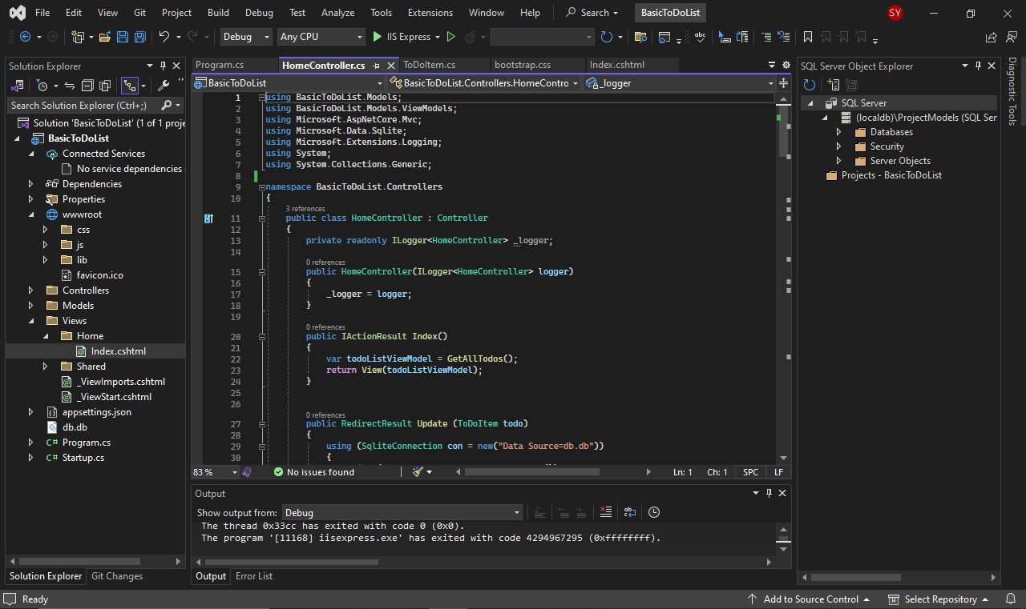

**5.2 View Class**

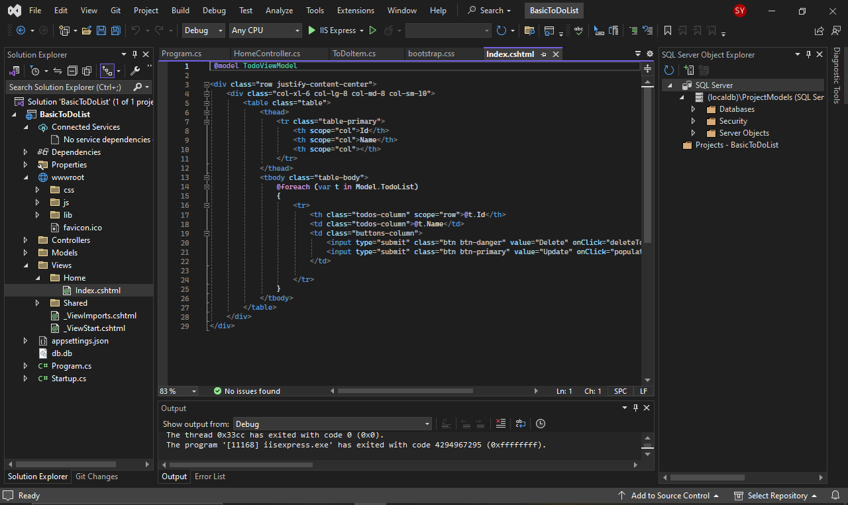

**5.3 Program Class**

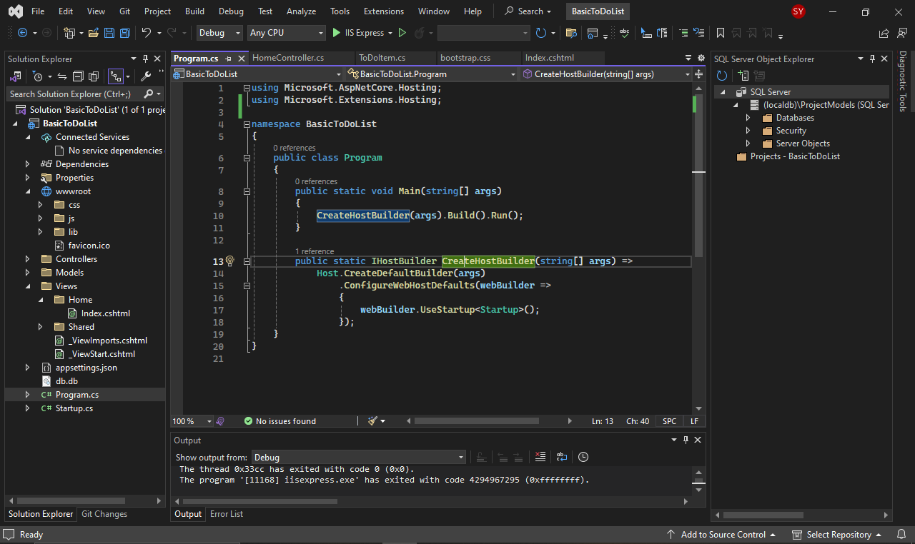

**5.4 Startup Class**

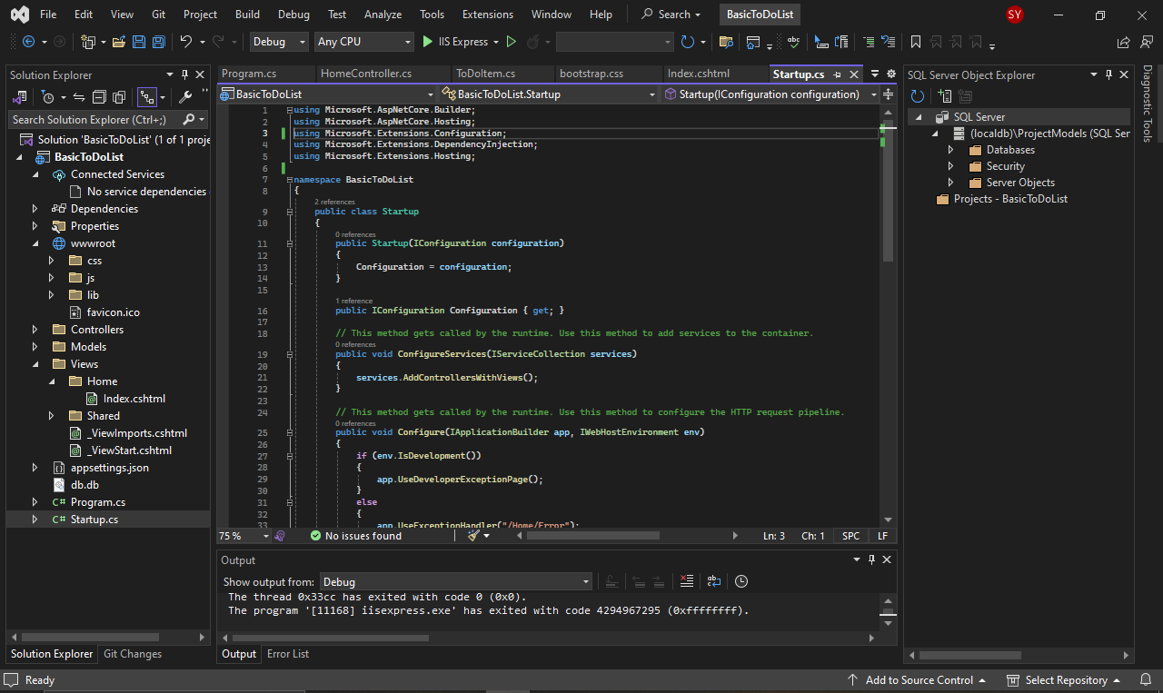

**5.5 Bootstrap**

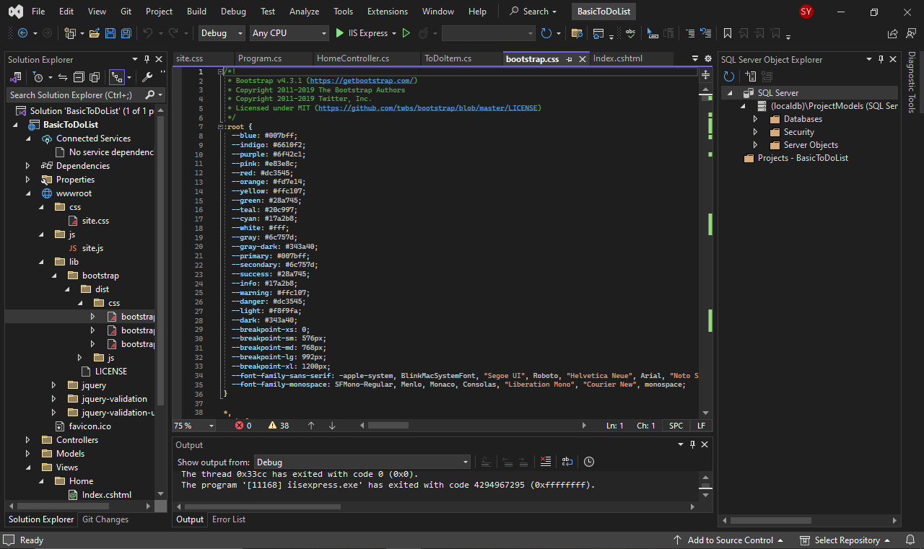

**5.6 Output (Localhost)**

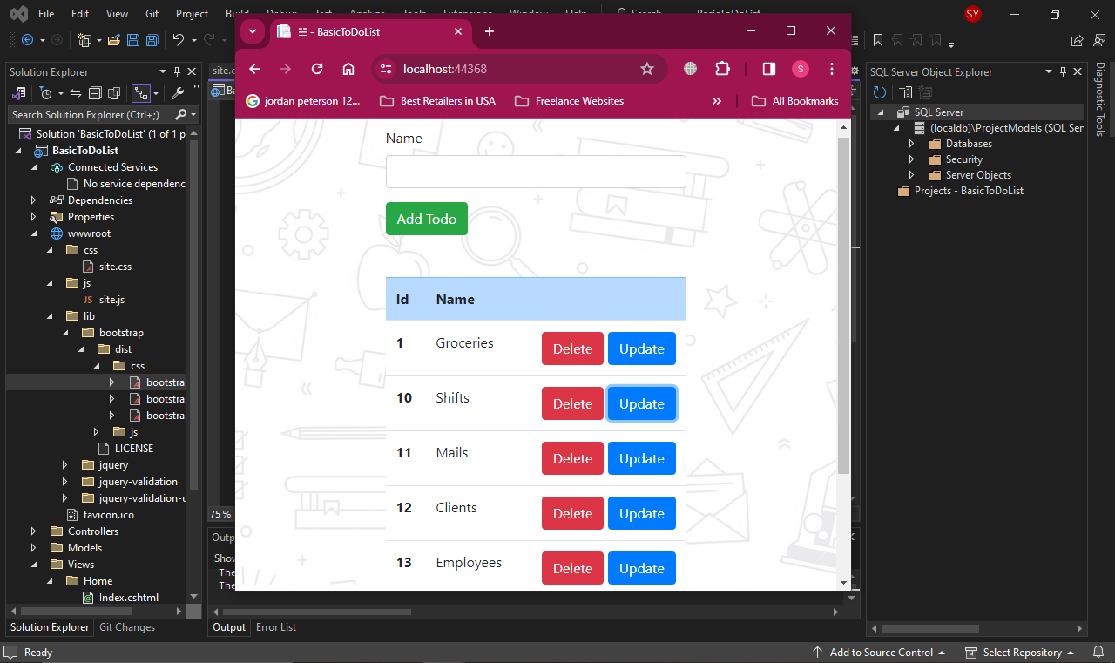

**Outcomes and Learnings:**

* Successfully developed a functional ToDo-List Web App using ASP.NET Core MVC and integrated it with a SQLite database for task management.
* Gained insights into MVC architecture, CRUD operations, and the deployment process to an external FTP server.
* Enhanced understanding of front-end and back-end interactions in a web application.